Conclusions of transcript 0, 6, 7

I found a total of **120** instantiations of argument schemes AS0-AS9. The most used argument scheme was AS2: Actor A has task T, but each argument scheme has been found back in the transcripts at least twice.

Of our critical questions, I only found back **9** instantiations. This could mean that our critical questions are somewhat artificial and probably not extremely useful in practice.

Additionally, I identified **85** statements that did not fit our existing argument schemes and critical questions, leading to **2** new argument schemes (**39** occurrences) and **8** new critical questions (**29** occurrences).

Finally, I identified **15** statements that introduced a specific topic of discussion. This could mean that our methodology could also propose topics to discuss, simply by asking things such as "What are the actors of the system?" or "What are the goals of actor A?"

# Existing argument schemes and critical questions

|  |  |  |  |  |
| --- | --- | --- | --- | --- |
| **Argument Schemes** | **0** | **6** | **7** | **total** |
| AS0: Actor | 2 | 2 | 5 | **9** |
| AS1: Resource | 2 | 4 | 5 | **11** |
| AS2: Task/action | 20 | 21 | 17 | **58** |
| AS3: Goal |  | 2 | 2 | **4** |
| AS4: Softgoal | 3 | 4 | 2 | **9** |
| AS5: Goal decomposes into Task | 4 |  | 4 | **8** |
| AS6: Task contributes to softgoal | 6 | 2 |  | **8** |
| AS7: Goal contributes to softgoal |  | 1 | 1 | **2** |
| AS8: Resource contributes to task |  | 4 | 3 | **7** |
| AS9: Actor depends on actor |  | 1 | 3 | **4** |
| **TOTAL** | 37 | 41 | 42 | **120** |

|  |  |  |  |  |
| --- | --- | --- | --- | --- |
| **Critical Questions** | **0** | **6** | **7** | **total** |
| CQ1: Is the resource available? |  |  |  |  |
| CQ2: Is the task possible? | 2 | 2 | 1 | **5** |
| CQ3: Can the desired goal be realized? |  |  |  |  |
| CQ4: Is the softgoal legitimate? |  |  |  |  |
| CQ5a: Does the task contribute to the the goal? |  | 1 |  | **1** |
| CQ5b: Are there alternative ways to realize the same goal? | 1 |  |  | **1** |
| CQ6a: Are there alternative ways to contribute to the same softgoal? |  |  |  |  |
| CQ6b: Does the task have negative side effects / same softgoal? |  |  |  |  |
| CQ6c: Does the task have negative side effects / other softgoal? | 2 |  |  | **2** |
| CQ6d: Does the task contribute to some other softgoal? |  |  |  |  |
| CQ7a: Does the goal contribute to the softgoal? |  |  |  |  |
| CQ7b: Does the goal contribute to some other softgoal? |  |  |  |  |
| CQ8a: Is the resource required in order to perform the task? |  |  |  |  |
| CQ8b: Can other resources be used for the task? |  |  |  |  |
| CQ9: Does the actor depend on any actors? |  |  |  |  |
| **TOTAL** | 5 | 2 | 1 | **9** |

# New argument schemes and critical questions

|  |  |  |  |  |
| --- | --- | --- | --- | --- |
| **Other annotations** | **0** | **6** | **7** | **total** |
| AS10: Task x-decomposes into task (x in {XOR,AND,OR}) | 11 | 14 | 11 | **36** |
| CQ10: Does the task decompose into other tasks? | 1 | 2 |  | **3** |
| AS11: Task contributes negatively to softgoal | 2 | 1 |  | **3** |
| AS*0: Topic introduction (e.g., "what are the actors?") | 5 | 3 | 7 | **15** |
| CQ*0: Is the decomposition correct (AND/OR/XOR)? | 1 |  | 1 | **2** |
| CQ*1: Is the element useful/relevant/redundant? | 2 | 3 | 2 | **7** |
| CQ*2: Is the description of an IE clear / specific enough / too specific? | 3 | 10 | 3 | **16** |
| CQ*3: Generic counterargument |  | 2 | 2 | **4** |
| **TOTAL** | 24 | 34 | 25 | **87** |

# Classification of Critical Questions

Critical questions can have different effects on the argument scheme they attack. However, some questions have a similar effect. We can distinguish the following groups.

## 1. Replace IE/Link

*Description.* This operation replaces the description of the intentional element, or it replaces the type of decomposition related.

*Formal.* Add an argument attacking the original argument for the element / relation, and all arguments preceding it. Decouple original argument from GRL element and attach new element to it.

*Critical question.*

- CQ6b, 12, 13, 15

*Example*

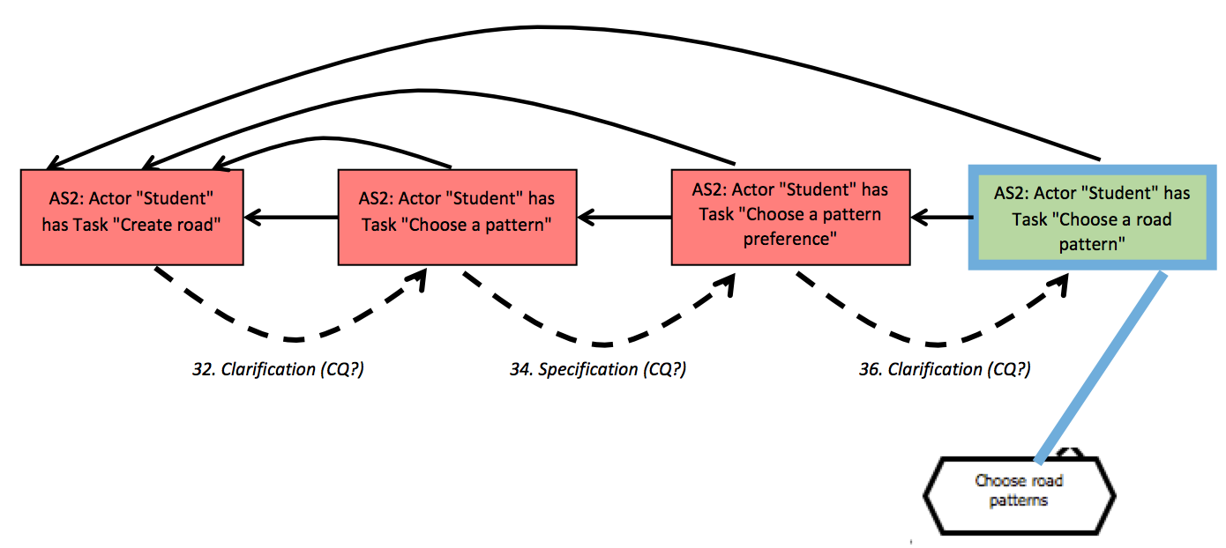Transcript 6 (Iterative clarification and specification)

Transcript 7 (decomposition)

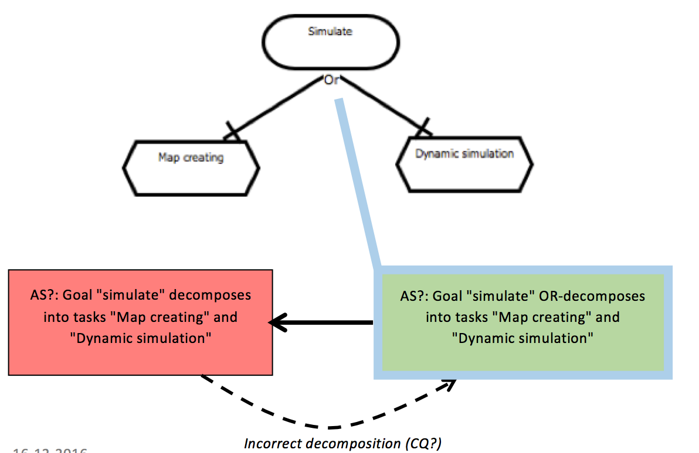

## 2. Disable IE/Link

*Description.* This operation disabled the IE or link.

*Formal.* Add an argument attacking the original argument for the element / relation, and all arguments preceding it. Decouple original argument from GRL element and attach new element to it. However, the new element forces the GRL element to be disabled.

*Critical question.*

- AS1,2,3,4,5a, 7a, 8a, 10, 11, 16

*Examples*

Transcript 0 (disable IE)

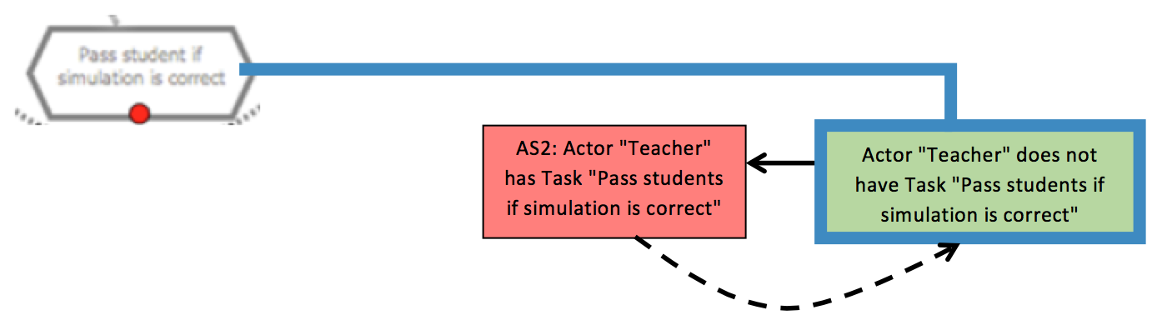

Transcript 7 (disable actor)

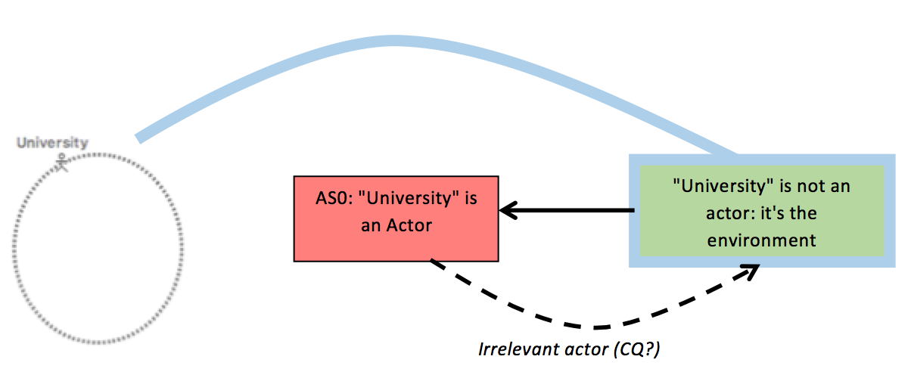

## 3. Introduce new IE(s)/Link(s)

*Description.* This operation does not attack anything, but generates new elements.

*Formal.* Add argumenta and corresponding GRL elements and possibly links, depending on the critical question. Couple the new arguments with the GRL elements and links.

*Critical question.*

- 5b, 6a, 6c, 6d, 7b, 8b, 9, 14

*Examples*

Transcript 7

This is a rather complex example containing various different arguments and crtiical questions.

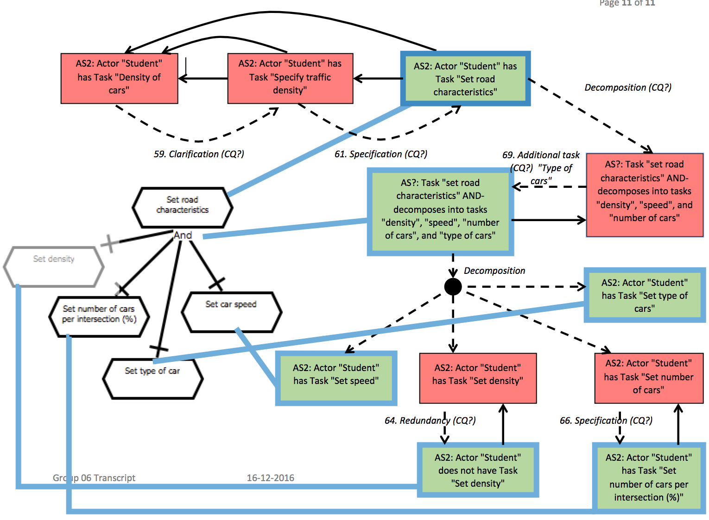

## 4. Generic counterargument

*Description.* Every argument can be attacked by a generic counter argument.

*Formal.* Add an argument attacking the original argument.

*Critical question.*

- none

*Examples*

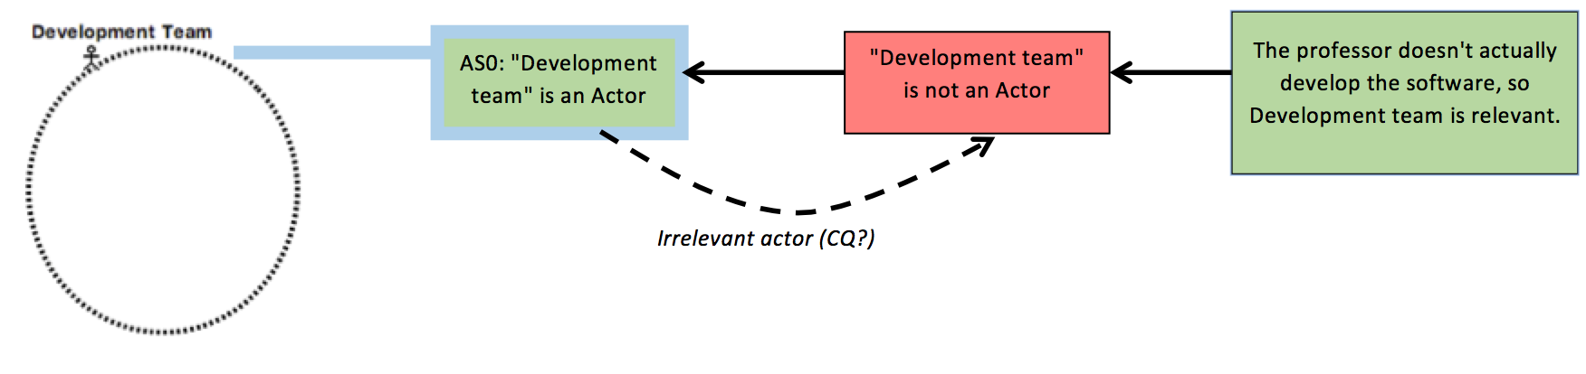The right most argument is a generic counterargument. It reinstates the left most argument, which corresponds to the Actor element.